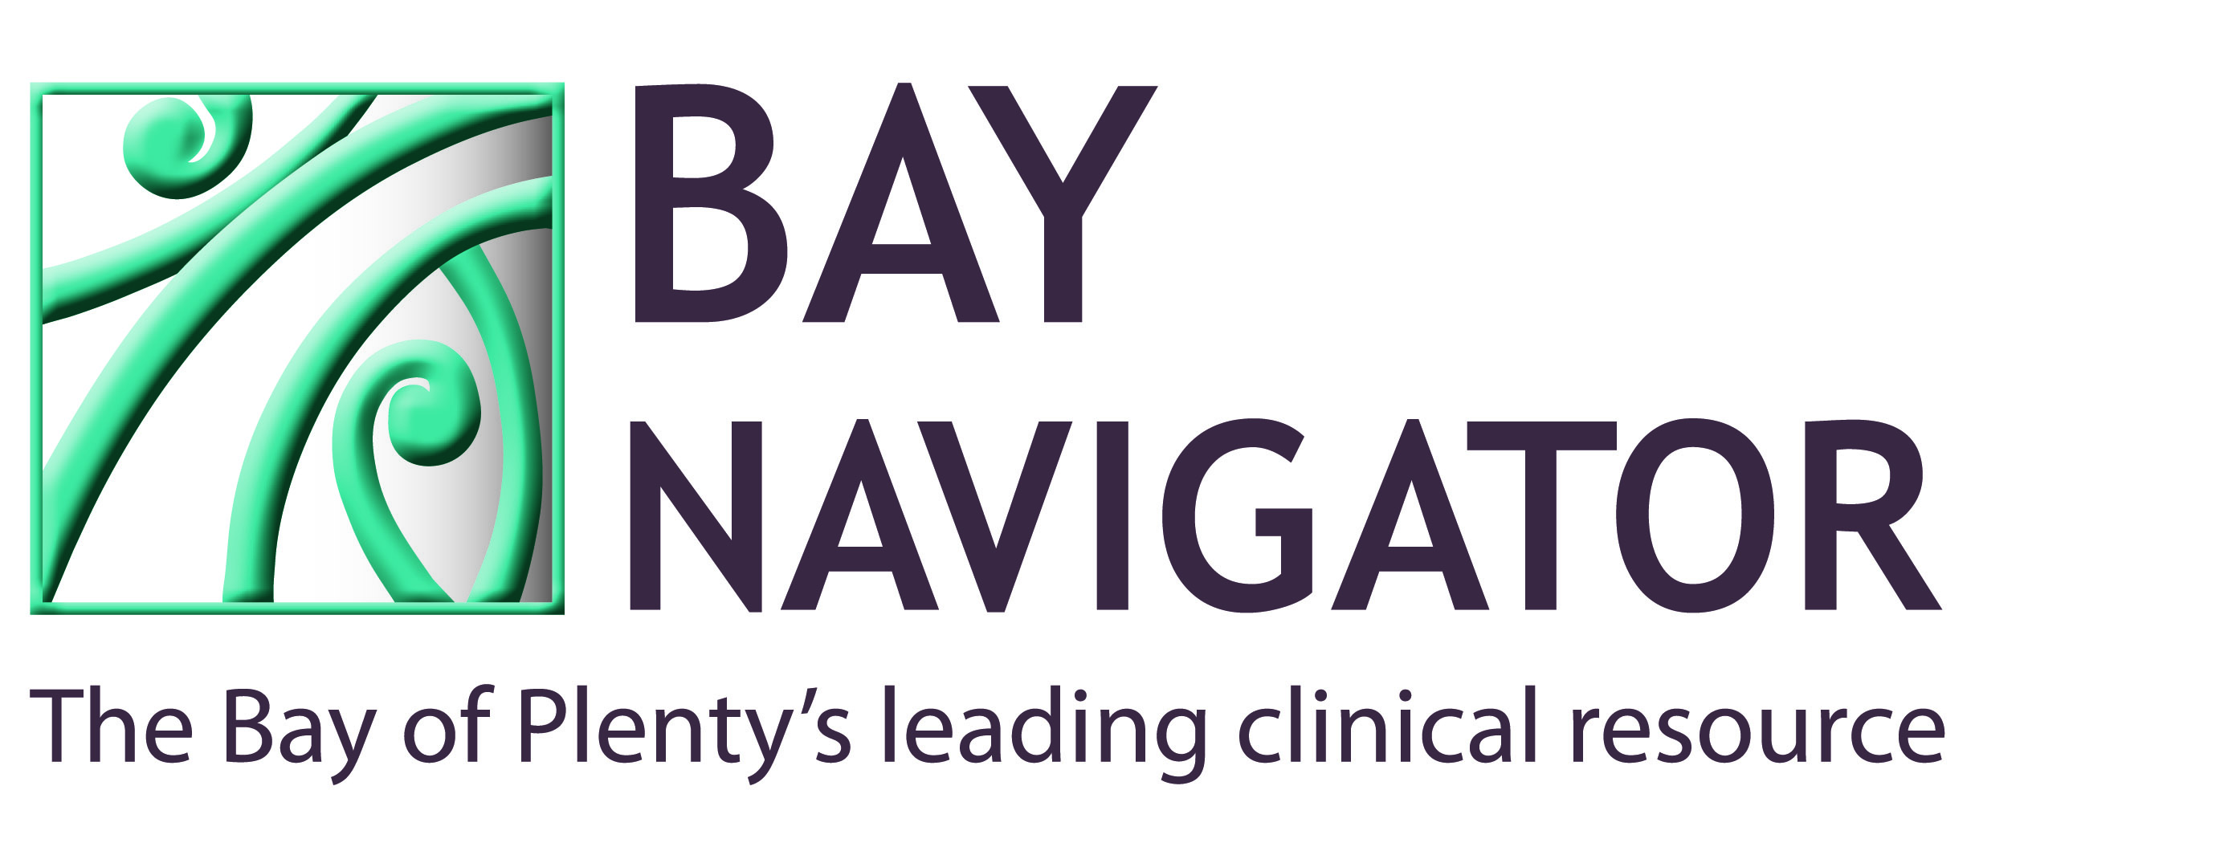
Zoledronic acid (Aclasta®) Infusion Check List

Date :
Staff Member:
Patient’s Name:
GP:

CHECK LIST RESPONSE

1. Has patient had their normal fluid intake such as water, tea and coffee ? Yes No
2. Is patient’s Clcr >35ml/min? Yes No
3. Is the patient on Vitamin D or had a loading dose of vitamin D? Yes No
4. Is their serum Calcium normal? Yes No
5. Have the patient’s questions been answered, after they have read the
Aclasta® Information Sheet? Yes No
6. Has the patient signed the consent form? Yes No
7. Has the patient been instructed to stop any oral bisphosphonate tablets
(if they had been currently taking them)? Yes No
8. Has the patient been advised to take Paracetamol 1g tds-qid for the next
3 days? Yes No

Renal Function and Hydration
- Clcr > 35ml/min: Administer standard Zoledronic acid dose. Dose reduction may be considered e.g. for very low bodyweight and/or variable renal function e.g. 35-50ml/min.
- Clcr < 35ml/min: Do not administer Zoledronic acid.
- Withhold diuretics, ACEIs and NSAIDs the morning of infusion to help prevent renal impairment.
- Advise patients to drink an extra 2 glasses of fluid on day of infusion to ensure good hydration.

Administration
- Zoledronic acid comes ready to administer, in 100mls of sodium chloride 0.9%.
- Using a metriset, prime tubing carefully to minimise loss
- Insert I.V. line and withdraw blood sample if required.
- Infuse contents of chamber over 30 minutes and on completion flush line with a further 20mls sodium chloride 0.9% through chamber.
- May be irritant to tissues if extravasation occurs.

Adapted from Auckland Bone Density and Primary Options NZ information

