**Background**

* Obesity growing concern for Ministry of Health
  + *Want general practice to weight their patients more regularly/address the issue of weight*
  + *Fear of offending patients, not being able to offer services, lack of appropriate scales*
* MOH put out ‘tender’ on ‘Supporting weight mgmt. in Primary Care’ with a brief:
  1. *Develop advice and resources for primary care PR actioners on how to raise the issue of weight mgmt. and communicate effectively with people*
  2. *Trail the tool in 10-15 practices (include high need, low income), evaluate and modify tool*
  3. *Roll out nationally*
* Universities and PHO’s from around NZ submitted weight management project proposals - WBoP PHO successful. Team: *Dietitians, GP’s, Nurses, pharmacists, exercise physiologists, nutrition researchers*
* Based upon the smoking cessation ‘ABC’ model – ask, brief intervention, cessation
  + *Simple brief advice from a health professional works (1/40 quit long term)*

**How the programme works**

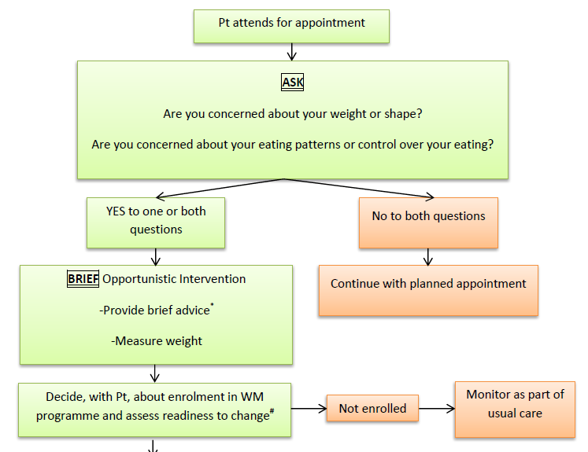

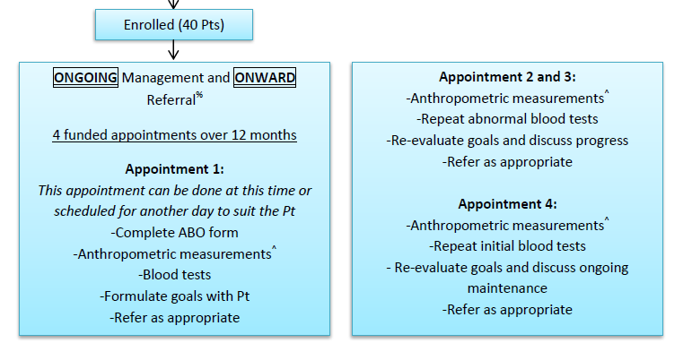

Patients who answer YES to one or both questions **AND** are ready to change can be enrolled in the weight management programme. *Patients who answered yes to questions but not ready to change will be asked again in 1 year.*

|  |
| --- |
| Compared to previous attempts to change your eating, how motivated are you to improve your eating at this time?   1. Not at all 2. Slightly 3. Somewhat 4. Quite 5. Extremely |
| Considering all outside factors at this time in your life (stress you are feeling at work, your family obligations, etc?) How confident are you that you will stay committed to an improved eating pattern program?   1. Not at all 2. Slightly 3. Somewhat 4. Quite 5. Extremely |

**Brief advice**

* Can be given at any time to any patients, don’t have to be part of weight mgmt. project
* Key messages are **POSITIVE**
* Eat more fruit and vegetables (more colours less beige resource)
* **No limits on coloured fruit and vegetables
* At least 5+ per day (3 veg, 2 fruit)
  + Increase to 9+ per day if possible (5-6 vege, 3-4 fruit)
  + Preserved, canned, dried options are acceptable
* Less is best with processed foods
* Move more
  + Slowly increase activity levels for those less sedentary but not currently meeting recommendations

Patient and health professional come up with goals (see POA/flash cards)

**During consult**: height, weight (using BIA scales that weight up to 270kg), WC

**Bloods ordered:** FBC, **ESR**, LFT (ALT, bilirubin, **AST, GGT, alk phos**), HbA1c, random glucose, Lipids (usual), Iron studies (Iron, morning transferrin/saturation), B12 & folate, TSH, uric acid, eGFR, albumin/creatinine ratio (urine).

**Bloods of note:**

* Liver enzymes: ALT usually raised in overweight fatty liver, AST – early inflammation
* HbA1c, uric acid, LDL, TAG: oxidant markers, can improve with high nutrient intake (antioxidants, plant chemicals). HbA1c can be used in pre-diabetics (weight loss properties)
* Folate – one of the few measures of fresh fruit and vegetable intake

**On-going Management**

* Funded for 4 visits of 12 months
* Comprehensive assessment form (based on Te whare tapa wha)
  + Weight, bloods, SMART goals – check in
* Recognises and addresses all areas associated with weight management
  + Beliefs/wairua around food and exercise
  + Whanau/friends as support
  + Hinengaro/mental health: hunger/eating cues, control over eating (addictions), emotional eating (depression/anxiety – Kessler 10, SCOFF)
  + Tinana/physical: binge eating/purging
  + Exercise patterns/attitudes
  + Sleeping patterns (sleep apnoea)
* Questions scored – relate to an appropriate plan of action e.g. sleep clinic referral

**Nutritional research base**

*Anne-Thea McGill – MBChB, BSc. PhD. FRNZCGP Practising General Practitioner, who over the past 15 years has developed experience in obesity and weight management in primary care. She has completed a PhD in clinical markers and cause of obesity related metabolic syndrome, and is Senior Clinical Investigator, researching the prevention of cardiovascular disease risk at the University of Auckland Human Nutrition Unit. Anne-Thea is also a Senior Lecturer at the Department of General Practice and Primary Health Care, School of Population Health, University of Auckland. She teaches about lifestyle diseases, particularly related to nutrition and physical activity and methods to facilitate behaviour change in Primary Care*

Positive simple message of eat more fruits and vegetables

*People used to being told what not to eat*

Eat whole/real nutrient dense food and minimise processed food

*An empathetic, non-blaming approach can be taken with people who are overweight with eating control issues, and at the same time they can be helped and enabled to find and eat much more whole food – particularly fruit and vegetables – without having to ‘calorie count’.*

* Many, if not most, individuals and families find the current food environment difficult, with the abundant, highly advertised, over-palatable and energy dense foods.
* The advice on healthy food is inconsistent with much misinformation available on the web but also the science can be contradictory and requires a consistent critique of current recommendations.
* Many biochemistry and epidemiological studies show a diet high in natural fibre, minerals, antioxidants and plant micronutrients reduces the risk for overweight conditions as well as diabetes, cancer and diseases of the liver, cardiovascular and neurological systems.
* Nutrient as opposed to energy content is emphasised. Core foods that are nutrient dense rather than energy dense foods are emphasised.
* There is now enough evidence for health professionals to translate the findings of many studies (including those based on evolutionary nutrition) on human nutritional behaviour and nutrient requirements.

Humans have special ways of increasing energy uptake and conserving energy. We have an expanded part of the brain that drives us to acquire (or latterly use technology to ‘make’) refined energy dense food. This same recently-evolved brain area (cortico-mesolimbic-striatal) includes the pleasure-reward-motivation-perseverance pathway, and affects many basic drives (eating rich foods, sex, but also (computer gaming, gambling). This system uses high levels of brain transmitters that are also chemicals of addiction The drivers of obesity are complex, however on stimulation by easily available over-appetising ‘moreish food’, humans can lose control of energy intake, ignore healthy food, gain weight and develop related diseases such as diabetes and cardiovascular disease.

* No one wants to lose control or gain weight but the drive is very strong in our environment, and hard to address with logic. (Nobody *logically* eats until overfull and overweight).
* Management of people with eating control problems needs to be understanding and compassionate.
* Non-judgemental help with pre-setting rules around addictions has been used with nicotine addiction and smoking cessation. We can help overweight people or those with eating control issues to
  + manage the difficult foods (which we all know what they are – think about what foods we go down to the dairy late at night for …)
  + manage stress (which worsens processed energy dense food control) and
  + encourage increasing consumption of non-addictive but tasty, healthy foods

This can be achieved through increased levels of micronutrients that are packed into healthy, minimally processed whole food. These micronutrients appear to make energy metabolism highly efficient in humans by ramping up a cell protection system. There is good evidence from cancer science that this high functioning anti-oxidant, anti-toxicant, cell repair system allows humans special longevity, protection from infection, diabetes, heart disease, cancers – in fact all degenerative disease *and* central obesity. Thus increasing whole foods, *especially* vegetables and fruit should be encouraged and supported at all times.

To improve health and manage weight (to achieve a healthy body weight), we need to eat a diet which is based on wholefoods and encourage people to eat in a way they can stick to long term. Contrary to the ‘calorie counting/portion control’ focus of many short term diets, we are focusing on the positive message of encouraging the consumption of whole, nutrient dense foods. Although these calorie restricted diets have proven benefits in the short term it is not realistic to rely on calorie counting in the long term. One of the key issues with poor nutrition is too much highly processed and refined food, confining these foods to a few special occasions would be ideal.

Humans have a surprisingly high requirement for micronutrients and phytochemicals that plants make to defend themselves from microbial attack. Fruit and vegetables are nutrient dense as these foods are high in both micronutrients and phytochemicals while being lower in energy value (i.e. lower in calories).

Highly coloured vegetables and fruit have high amounts of phytochemicals and a diet high in micronutrients and phytochemicals including antioxidants may increase health status and potential lifespan by decreasing inflammation and risk of disease. Freshly prepared and lightly cooked vegetables may be the best source of phytochemicals (antioxidants).

A dietary pattern high in fruit and vegetables and therefore high nutrient density may prevent weight gain. Foods can be preserved by drying, freezing, bottling, pickling and fermenting. But avoid heavy syrups when bottling and sugar cured or smoked meats and fish.

* All highly *energy* restricted diets will cause weight loss – humans have a high energy turnover, but good metabolism depends on enough energy with plenty of natural, whole food nutrients (not pills and supplements)
* Shrinking a bad diet i.e. less low nutrient dense food does not make for health or sustainability of weight loss

**Workbook for general practice**

ABO workbook developed for general practice to give them more information on nutrition, exercise, sleep, bariatric surgery, VLED, weight management medications, Maori and Pacific considerations, food addictions.

Nutrition section divided into macronutrients then ‘tips’ relating to specific foods e.g. fruits and veges, meat, nuts/seeds, legumes.

Currently workbook going back and forth with MOH.