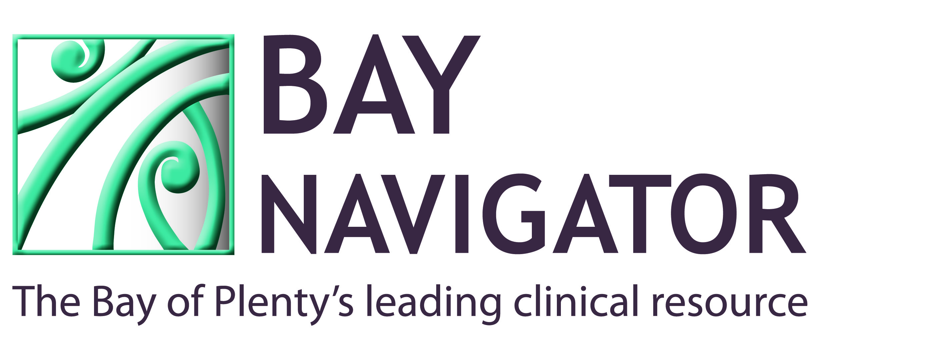

PATIENT INFORMATION SHEET - ZOLEDRONATE (ACLASTA®)

Zoledronic acid strengthens bones and prevents fractures in people with osteoporosis.

Zoledronic acid is given by an intravenous infusion (into a vein in the arm via a “drip”) over about 30 minutes.

Possible side effects:
1. About 30% of individuals may experience a flu-like feeling after their first treatment which usually last 24-72 hours but which can occasionally go on for longer, sometimes with associated muscle or joint aching. This usually responds well to regular paracetamol or an anti-inflammatory such as ibuprofen (Nurofen®) or diclofenac (Voltaren® or Diclax®). The chance of this side-effect occurring after second or third zoledronic acid infusions is much lower.

2. Individuals with severe pre-existing kidney damage and/or dehydration can sometimes experience deterioration in their kidney function after the administration of zoledronic acid. It is normal practice not to use zoledronic acid in people whose kidneys are not functioning well.

VERY RARE side effects:
3. Upper leg fractures have been reported but zoledronic acid prevents far more fractures than it causes.

4. Osteonecrosis of the jaw (ulceration in tooth sockets or the gums) has occurred (mainly in cancer patients receiving much higher doses of zoledronic acid than those used for osteoporosis). Factors known to increase risk of osteonecrosis of the jaw include poor dental hygiene, mouth infection, major dental work and prolonged steroid use (e.g. prednisone).

5. Medicines in the same family as zoledronic acid can cause eye inflammation (uveitis, scleritis, conjunctivitis).

If you have any other questions about this medicine, or your bone condition, you should feel free to ask your doctor.

Adapted from Auckland Bone Density and Primary Options NZ information

